Project Design Phase-II
Data Flow Diagram & User Stories

Date | 26 June 2026
Team ID
Project Name | Student Leave Request Management
Maximum Marks | 4 Marks

Data Flow Diagrams: A Data Flow Diagram (DFD) is a traditional visual representation of the information flows within a system. A neat and clear DFD can depict the right amount of the system requirement graphically. It shows how data enters and leaves the system, what changes the information, and where data is stored.
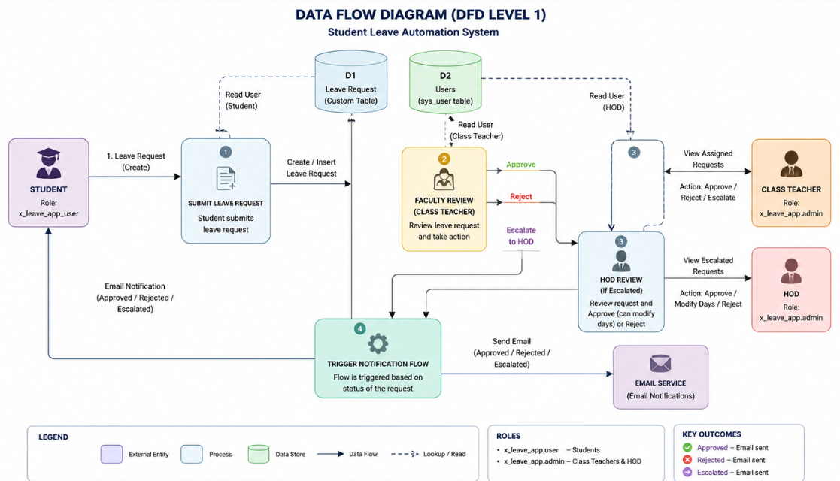

User Stories
Use the below template to list all the user stories for the product.
User Type | Functional Requirement (Epic) | User Story Number | User Story / Task | Acceptance criteria | Priority | Release
Customer (Mobile user) | Registration | USN-1 | As a user, I can register for the application by entering my email, password, and confirming my password. | I can access my account / dashboard | High | Sprint-1
 | Creation of requests | USN-2 | As a user, I will be able to create leave requests whenever I deem necessary. | I can create leave requests | High | Sprint-1
 | Request analysis and response | USN-3 | As a user, I will be able to review student’s request and accept/escalate/reject based on criteria. | I can review the leave request and act accordingly. | High | Sprint-2
 | Timely notifications of leave status | USN-4 | As a user, I should be able to receive update on, my leave request via email | I can receive mails regarding my leave application status. | High | Sprint-2
 | Access Control | USN-5 | As a user, I can access information which is designated to me by my role i.e, student, class teacher, hod | I am given access to modules based on my roles. | Medium | Sprint-3
 | Dashboard
Customer (Web user)
Customer Care Executive
Administrator

